

Study Buddy

*Online Study Tracker*

Table of Contents

**Background** **4**

Project Proposal 4

Team Principles 4

**Planning** **5**

Team 5

Composition 5

Roles and Responsibilities 5

Project Phases 6

Project Management 6

Scrum 7

Kanban 7

Waterfall 8

**Research** **9**

Persona (Example of a user) 9

User groups 10

**Prototyping and Iteration** **11**

**Design** **15**

Front-End 15

Design Purpose 15

Design Languages 15

Back-End 16

Technologies 16

Hosting analysis and decisions 18

Data Layer Analysis and decisions 19

Back-end analysis and decisions 19

Database 21

Testing 25

First Sprint 25

Second Sprint 25

**System Development** **26**

First Sprint (Login & Sign up Users) 26

Front-End 26

Login / Sign up Design 27

Icons Design 27

Required Attribute 28

Hovering 28

Media Design 29

Back-End 29

Retrospective 30

Testing 31

**Second Sprint (Overview & Add Module & Add Task)** **35**

Front-End 35

Add Module / Add Tasks Design 35

Add Module 36

Add Tasks 37

Progress bar 37

Back-End 37

Retrospective 38

Testing 39

Functional Test Procedures 39

User Test Procedures 42

HTML Testing 43

**Analysis** **45**

Risk Assessment 48

Risk occurrences 50

**Evaluation** **52**

Process 52

Product 53

End User Product Evaluation 53

Internal User Product evaluation 54

Front-End 55

Evaluating Design 55

Back-End 56

Testing 57

**Conclusion / Summary** **58**

Outcomes 58

Development Practice 58

Future Plans 58

**Appendix - User Manual** **59**

# Background

## Project Proposal

Study Buddy is an App that assists students with organising their studies. Students can create their own accounts and add the UoL/Coursera modules they are currently studying.

* The App will create an overview of the Modules in a list and provide the students with a personalised overview including tasks, deadlines and exam dates among others.
* The App will also be able to send reminders in an email or pop-up message form.
* The App will provide the student with general information about the module itself in a module page.
* Upon finishing the module students can remove it from their list and add the ones they chose for the next term.

## Team Principles

The team consists of 5 individuals with heavy workload in their personal as well as professional life. Having already had experiences of project successes and failures in our professional lives we initiated working on the Final Assignment by defining our team principles.

Trust among the team had already been established during the Midterm Assignment phase and we had built up the confidence of a high performing team.

What we learnt about how we work together was that we had to be very careful around planning and attending in order to accommodate each other. Moreover, we have a big experience gap within the team when it comes to programming. When it comes to principles we agreed the following during our first meeting:

**Alignment**

Life happens! We know where we are in the process, what are the next steps and we inform each other as soon as possible if we are unavailable.

**Accountability**

We know exactly which tasks are assigned to us and we finish the meetings shortly telling each other what we will do until we meet again. We are not afraid to speak up, take on daunting tasks and ask for assistance.

**Assistance**

The team is here to cover for each other. We communicate difficulties as soon as possible so that we can get help.

# Planning

## Team

### Composition

Our team consists of 5 individuals with different professional backgrounds and specialist skills. Having already worked together for the first half of the term we had built rapport and trust allowing us to work in an even better way. We decided to keep our weekly check in meetings on Mondays at 17:30 CEST for 30 mins, extending whenever necessary. The choice of day and time was in order to accommodate constraints around working patterns, as well as time zone differences since the team was residing in 3 continents.

### Roles and Responsibilities

Having a good understanding of what the task was and building on the experience we had accumulated by working together the first half of the term we met to distribute the roles and amend the RACI model we had already utilised.

The RACI model is a straightforward tool used for identifying roles and Responsibilities and avoiding confusion during a project. The Acronym RACI stands for:

* Responsible: The person who does the work to achieve the task. They have responsibility for getting the work done or decision made. As a rule this is one person.
* Accountable: The person who is accountable for the correct and thorough completion of the task. This must be one person and is often the project executive or project sponsor. This is the role that responsible is accountable to and approves their work.
* Consulted: The people who provide information for the project and with whom there is two-way communication. This is usually several people, often subject matter experts.
* Informed: The people kept informed of progress and with whom there is one-way communication. These are people that are affected by the outcome of the tasks, so need to be kept up-to-date.

Source: <https://www.projectsmart.co.uk/raci-matrix.php>

For each planned activity we discussed what our roles and responsibilities are, how the sub-teams will be formed and who is accountable for reaching out to team members for input as well as for delivering the final piece of work for each activity. The agreed split can be seen below:

| Domain | PM (Andreas) | PO (Max) | Tech Lead (Robert) | UX (Swalin) | QA (Jorge) |
| --- | --- | --- | --- | --- | --- |
| Process | A/R | C | I | I | I |
| Product | C | A/R | C | C | C |
| Front-End | I | A | C | R | I |
| Back-End | I | C | A/R | I | I |
| Testing | I | I | C | C | A/R |

The above does not mean that the team members were limited to their roles. The team was working in a very collaborative manner with our Slack channel being very active and team members assisting each other.

## Project Phases

In an effort to optimise the process as well as equally distribute the areas of responsibility we took a holistic approach and split the project into 6 Phases.

1. Planning
2. System Analysis
3. System Design
4. Development
5. Testing
6. Implementation

The first 3 Phases of the Project include the activities the team must perform in order to reach the Project Proposal milestone (Midterm Assessment) and the rest of the Phases correspond to the delivery of the MVP of the product (Final Assessment).

## Project Management

In order to manage this agile development project we were faced with the question which strategy we would choose. The whole team already had experience using scrum, kanban and waterfall and we had a very interesting dialogue on what would be the best approach for the task in hand. We chose a hybrid, combining elements of both scrum and kanban along with a waterfall tool. The rationale explained below.

### Scrum

In order to utilise our resources (time) more efficiently we created a backlog of tasks which then got bundled up and assigned to two sprints.

**Sprint 1**: Log-in & Sign-Up

**Spring 2**: Overview & Add Module

With this split of sprints we made sure that we would be working towards delivering a working product after each iteration.

### Kanban

An element of Kanban that we decided to implement was a Trello Board. This was important in order for the team to have a working workflow and visualise the bigger picture. Although the Scrum Sprints are indeed self sufficient there was a need for all involved parties to avoid tunnel vision and maintain an understanding of the whole process. The steps on the Board were 4:

1. Backlog
2. In Progress
3. QA / Testing
4. Done

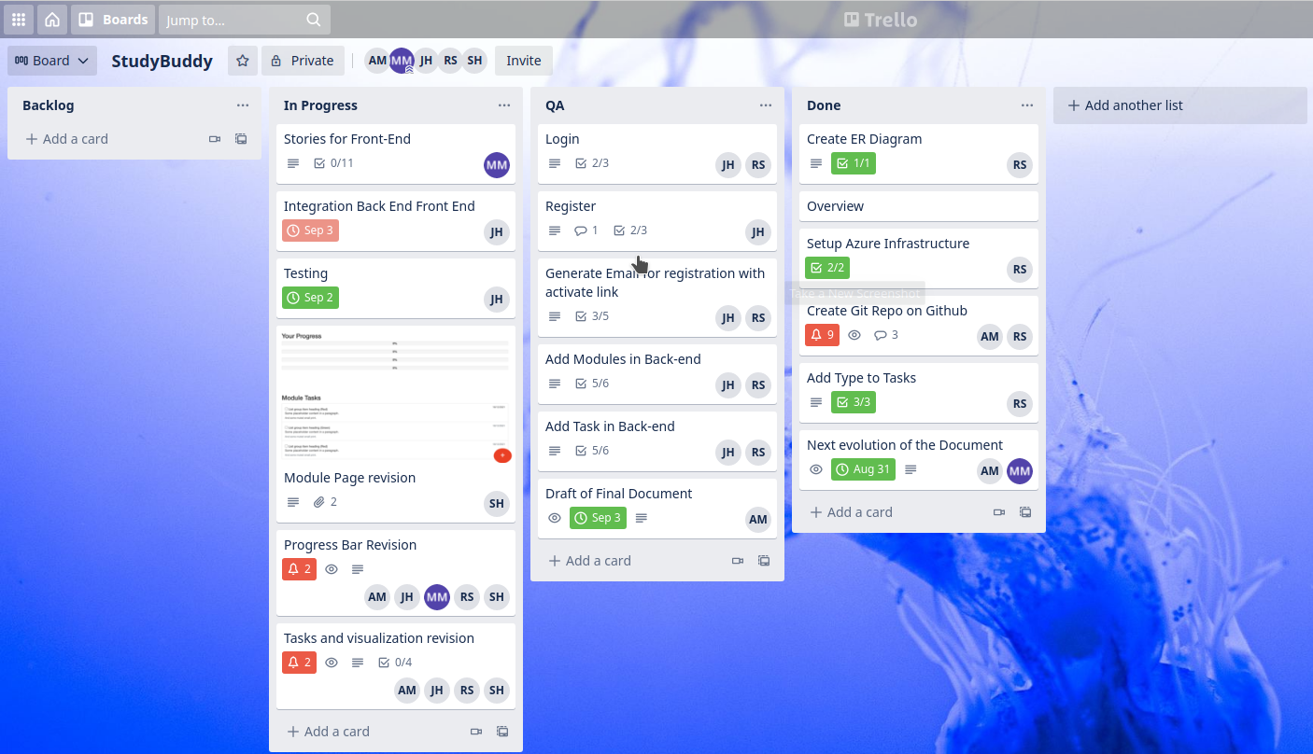

### Waterfall

Last but not least, although the setup was sufficient we realised that both systems do have limitations when it comes to dealing with time and overall project deadlines. Although the deadlines are set for each task separately, an overall time planning became imperative if we were to adhere to the strict deadline of our final submission. We used a traditional Gantt chart to make our general planning and plotted the Sprints, as well as revisions in it, along with Milestones and buffer time to account for Risks.

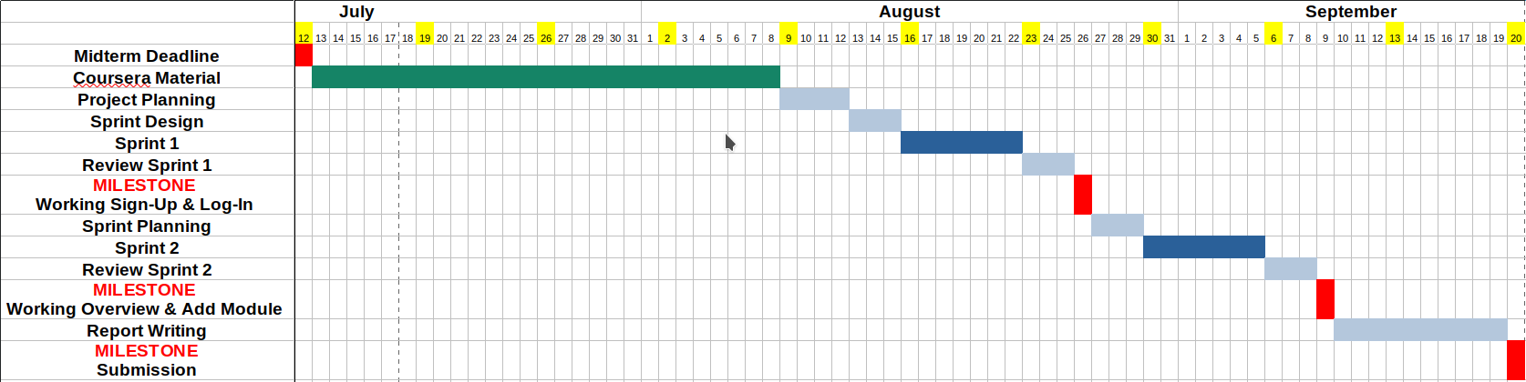

# 

# Research

## Persona (Example of a user)

Michelle is a Part-Time working Student that needs reliable application to keep track of her studying progress and can easily access all day long 24/7. Michelle does not have a reliable Management Interface which preserves track of her progress, schedule, due dates, since the whole process is done manually through (paper and pen) as she is responsible for, writing all the information by hand on paper and mistakes often happen.

So Michelle wants to be able to have an overview of her registered Modules (courses). Also she needs an efficient way to keep track of her exam, assignments due dates and deadlines.

User Questionnaire

We utilized an online questionnaire as our approach and methodology for gathering data from possible end-users as:

1. It’s fast and efficient in gathering data from participants who are located in remote locations.
2. It is appropriate for the nature of our intended end-users (E-learning Students), who are overwhelmed with the unformatted class dates, assignments, and examinations, and who are constantly forgetting a lecture or upcoming exam.
3. With few resources, it is possible to reach a large number of end-users.

Noting that our major goal and purpose in performing such research is to produce an easy-to-use application with an interactive interface. And to obtain a knowledge of the requirements, needs and behaviors of diverse end-users.

The following questions were asked to each user:

* Please select your age range
* Please Select your Learning Style
* Are you a full-time student or do you have a (part/full time) job?
* How Many modules are you studying in each term?
* How do you track your Studying progress?
* In case of using a third party app. to track your study progress, how frequent do you use it?
* How much time do you typically spend on tracking your study progress rate / Weekly? How interested would you be in a Study tracking app to keep tracking your learning progress?
* What are the most important features the Study tracker application should have?
* What kind of user-interface would you prefer the Study tracker application to be on?

## User groups

Based on our Questionnaire analysis and the responses of more than 40 participants to our questionnaire, we have concluded that our target consumers are as follows.

| User group | Background | Use of the system | Environment | Main goals |
| --- | --- | --- | --- | --- |
| Students | **Age:** 18+    Gender:  All genders | **Usage:** All year round  **User skills**:  Beginner **Attitude:** Positive since it simplifies the way data is displayed and provides a better user interface  **Number of users:** All Students | Technical environment:  To have access to the device and an internet connection | Students Ability to log in/Register using the website, access to the Modules section to track his Studying Progress and his due dates. |

# 

# 

# Prototyping and Iteration

The prototype was built through two scrum iterations, below a screenshot of the kanban board taken as one of the first iteration was almost completed:

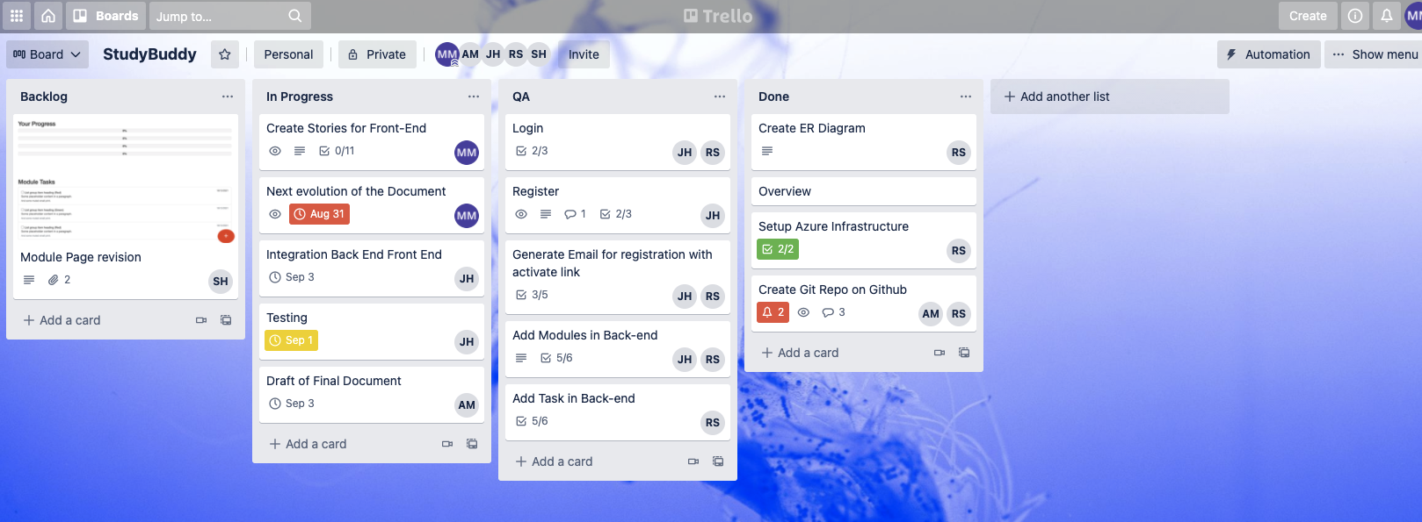

The activities were organized as user stories configured as tasks for each card as shown in the screenshot below.

Starting from the prototype submitted for Midterm we built an initial list of user stories that described the general functioning and the inner functioning of the system for all actors and all processes identified, during the following iterations discrepancies and issues where discovered and an incremental evolution approach was used in order to reach a level of functionality and usability that was satisfactory.

The team as described earlier has adopted a clear role model therefore it was fairly easy to understand the points that needed additional work and refine the level of granularity of description when needed.

The final step was to make sure that the system was compliant with the initial requirements and in line with the subsequent change requests therefore able to go through a final acceptance.

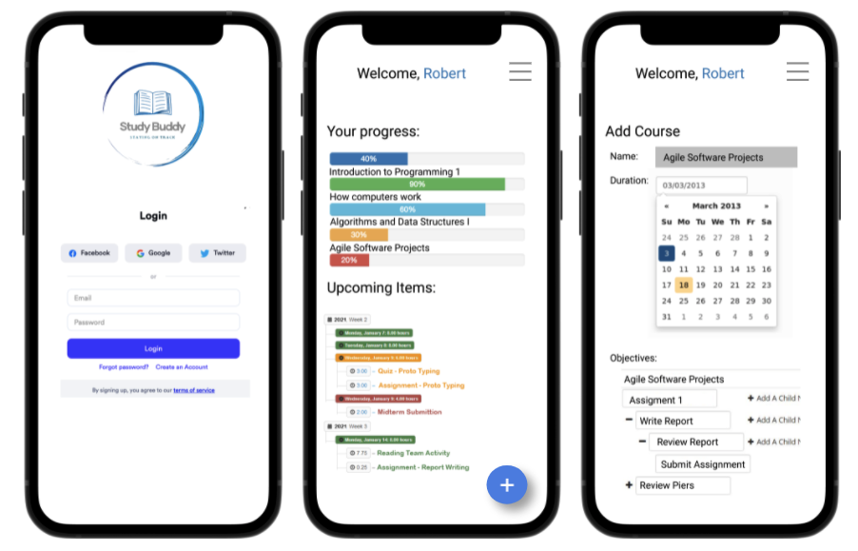

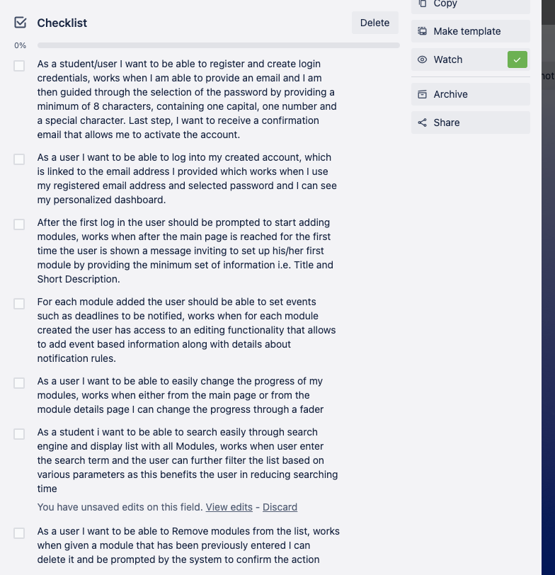

In order to align the developments with the scope drafted for Midterm the scope features were detailed and used as guidelines as shown in the screenshot below.

# 

Github was used to version control the code.

# 

# Design

## Front-End

The design phase will utilize the user needs analysis in order to make the most effective product possible. This phase will focus on the specificity of the Study Buddy app (Study Tracking) and how it can be made in the most user-friendly way possible, as well as optimizing its efficiency. It is crucial in this phase that all targeted users (Middle Age Students) can use this app efficiently.

### Design Purpose

Our Design major goal is to keep track of the necessary information to properly describe the architecture of our system in order to provide direction and guidance to the development team on the architecture of the system to be developed.

Our Front-end Designs are incrementally and iteratively produced during the *SDLC* (system development life cycle), based on the particular and targeted user feedback.

### Design Languages

After several meetings and discussions, we made the decision to employ these front-end languages.

1. **HTML5** will be used for the structure of the page and will consist of a series of different elements to show the intended structure of the page. It also provides a number of benefits that will support our project.

a. The browser would be *unsure and unable* to display the content correctly, without HTML elements and structure.

b. It’s Ability to Integrate with other languages.

c. Simple to use

2. **CSS3** will describe how the HTML elements on the site are displayed and presented onto the screen. It also provides a number of benefits that will assist our project.

a. Using CSS can *save and reduce the amount of work*. This can be done by controlling the layout of multiple web pages all at one time.

b. Multiple Browser Support

c. Speed

3. **JavaScript**, one of the most important and popular of front end development languages due to:-

a. Its ability to *create dynamic and responsive web pages*. Not only are interactive web pages fantastic for user experience, but this useful addition can also play dividends when it comes to paid advertising.

b. Its capability to give you Extended Functionality.

4. **JQuery** is a JavaScript library that allows us to write less code and create sleeker sites. With a unique ability to simplify programming, it’s more favourable due to:-

a. Its ease and user-friendliness.

b. Cross-browser compatibility.

c. Fast page Speed.

5. **JSON** is JavaScript Object Notation. It will be used for serializing and transmitting structured data over a network connection. It’s primarily to transmit data between a server and web application. It is a much-more compact way of transmitting sets of data across network connections as compared to XML

## Back-End

### Technologies

Once we decided on the application we are building, we needed to find a way to make this accessible to all users, making it as easy as possible for the evaluator of the software to access it with the least amount of effort. The Azure platform will also be used for the final product we launch to the public.

We decided to go with the Microsoft Stack for hosting as this offers us a free trial and, based on the internal skill set of the team, was the quickest go to market strategy to implement.

We evaluated and chose Azure for hosting the application, as illustrated below, as this offered us the ability to create an App Service to host our business layer of the application by using a .NET Core API. Our Data Layer resides in a SQL Server with a SQL database component.

Security and access are all controlled via the resource group in Azure, making it quick and easy for us to manage who has access to our services being hosted in the cloud. We have nth level control down to controlling which countries can access the hosted application and users.

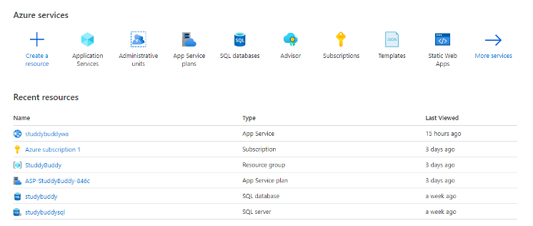

Azure also allows us to monitor traffic to the application and be pre-emotive in attacks to our service or servicing the required load based on the popularity of our application, and we are hoping that the latter will happen, in which case we can easily upscale our solution.

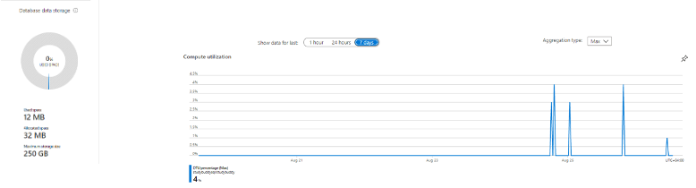

The Azure Dashboard provides us monitor and configuration ability on the fly.

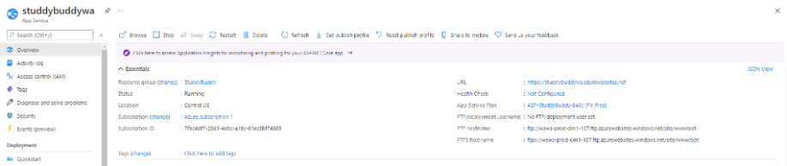

The technologies used for the core component of the application is as follow:

· Hosting

o Azure Hosting

§ App Service

§ SQL Server

§ SQL Database

§ Resource Group

· Security

o Resource group control

· Data Layer

o SQL Server

o SQL Database

· Back-end REST API service

o App Service Hosting container

o .Net Core API, which is platform-independent

· Presentation Layer

o HTML / Bootstrap CSS / JS / jQuery / JSON

During the evaluation phase of the technologies, we had to make decisions based on the team's expertise and ease of implementation and turnaround time in getting us started as quickly as possible due to tight timelines and deadlines.

### Hosting analysis and decisions

We chose to go with Azure as this offered us a free trial period of a year, and team members had experience with the platform. Amazon Web Service and Platform had a cost to it, and limited internal expertise was available. Our assessment was as follow:

· Azure:

o Expertise available

o Free 12-month trial

o Ease of use and accessibility

o Lots of Platforms available (Unix, Linux, Windows)

o Security controls

o Highly configurable

· Amazon Web Services

o Platform-Specific

o Lack of internal expertise

· Independent hosting

o Long setup time

o Not guaranteed uptime as hosted by team member

o Security setup and access is complicated and requires cost

o Not reliable

### Data Layer Analysis and decisions

We knew from the start that we would be using a structured query language to store and access data, but we need to decide on the technology to use. We choose to go with SQL server as the choice for database and hosting this on an Azure SQL server. Our assessment was as follow:

· MongoDB

o Transactions using MongoDB are complex

o MongoDB is not a strong ACID (Atomic, Consistency, Isolation & Durability) compared to many other RDBMS systems.

o Transactions using MongoDB are complex

o In MongoDB, there is no provision for Stored Procedures or functions, so you can't implement any business logic at the database level, which you can do in any RDBMS system.

· MySQL

o Transactions related to the system catalogs are not ACID compliant

o Sometimes a server crash can corrupt the system catalogue

o Stored procedures are not cacheable

o MYSQL tables which are used for the procedure or trigger are most pre-locked.

· Azure SQL

o Scalability and Beyond

o Support Direct Integration with Developer Environment

o High Speed and Minimal Down Time

o Improved Usability

o Intelligent Protection with added security

o Internal Expertise within the Team

### Back-end analysis and decisions

We need to find a relevant technology in the market and accessible for us to use and implement to get us started as quickly as possible to prevent delays between the front-end and back-end development. We decided to go with a REST-API service. We developed the signature and methods as a framework available to the front-end to start independently of the parallel back-end development. We decided to go with .NET Core API instead of Node.js for the following reasons: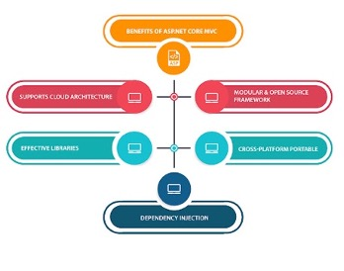

.NET Core API

o Support on Azure

o .NET Core is Cross-Platform

o .NET Core is Open Source

o Mature Framework and Widely Used Programming Languages

o The .NET Core Supports a Wide Range of Application Types

o Increased security with .NET Core

o .NET Core Enables Top App Performance

o .NET Core Enables Flexibility

o .NET Core is Cost-Effective

o .NET Core has a Large Community

The solution for our application consists of the following core components: 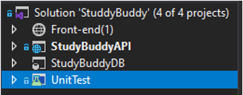

· Web Application

· Web REST API Service

· Database Project

· Testing project

Please refer to the Front-end application section for more details on the structure and technologies used.

In planning for the back-end services, the first thing that was needed was to define the interface and the requirement methods based on the project's use cases, as this was the primary driver in the development of the application.

The design phase was the most critical part of the internal session we had as a development team. We used the Trello board to keep track of the development of each item.

The .NET Core API project (**Rest API Service**) contains the following components: 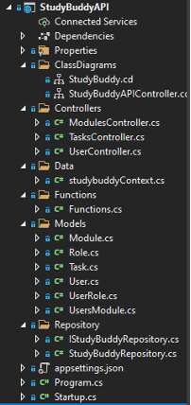

· Interface with defined methods available for consumption by the front-end service

· Controller classes

o User Controller (User functionality, CRUD)

o Module Controller (Module functionality CRUD)

o Task Controller (Task functionality CRUD)

· Repository Class (Handling Database connections and CRUD)

· Functions (Shared Library for classes to use standard functions)

· Start-up (configuration class to set security, available routes)

As part of the design phase, we created class diagrams to showcase how all the service components will fit together with our modular approach and interface design goals.

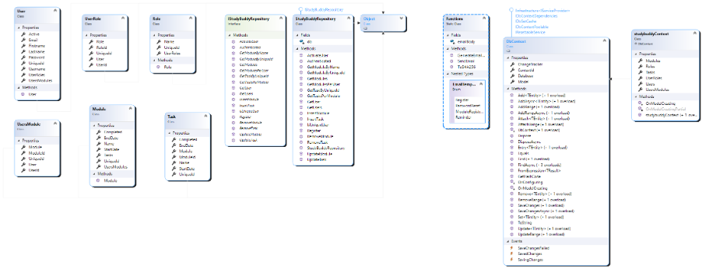

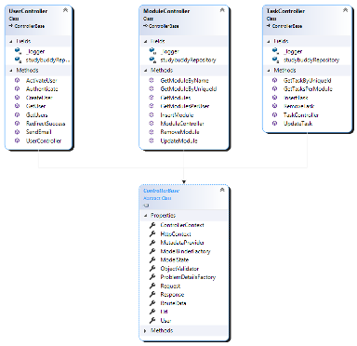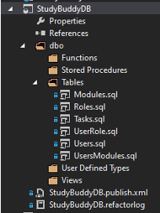

### Database

The **Database project** consists of the tables and their table definitions for our applications. The table definition contains the details on the data types and primary keys, and relationships between tables.

We created the project to allow us to implement changes quickly and to publish this to our hosted azure database server as we perform iterations on the project.

The database design can be seen in the ERD diagram below:

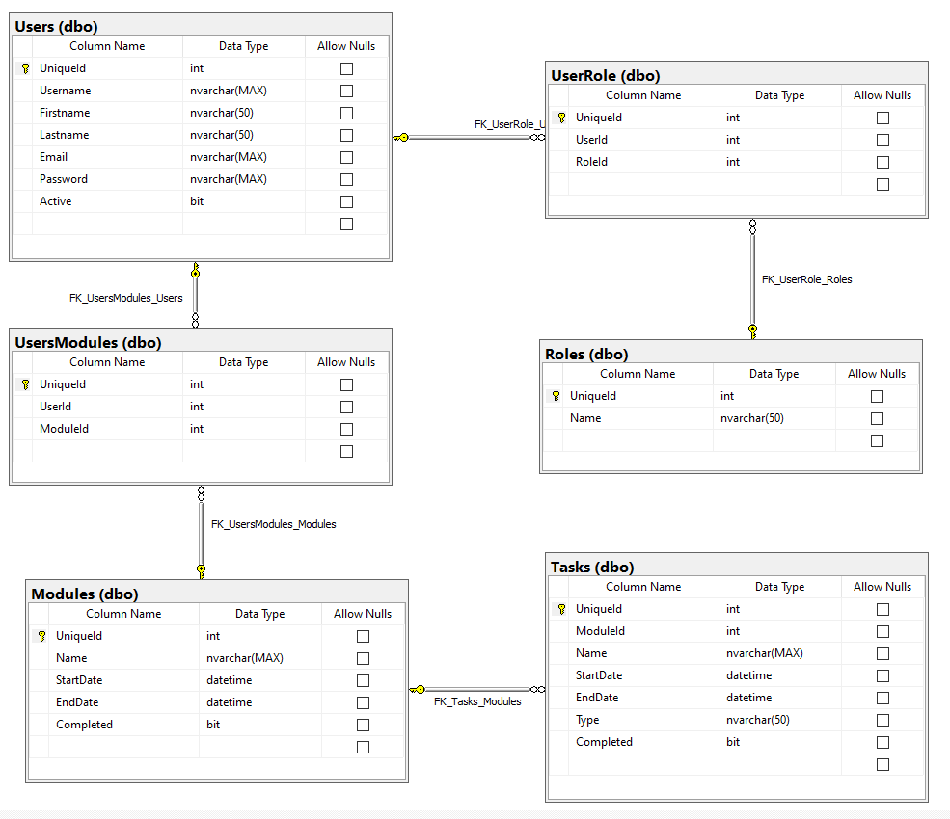

The process that was followed for the development lifecycle was using a sprint with 2-week iterations. We implemented a Trello board to keep track of tasks and progress on individual items. We as a team decided to use GitHub as our choice of repository to allow us all to work remotely on our respective tasks.

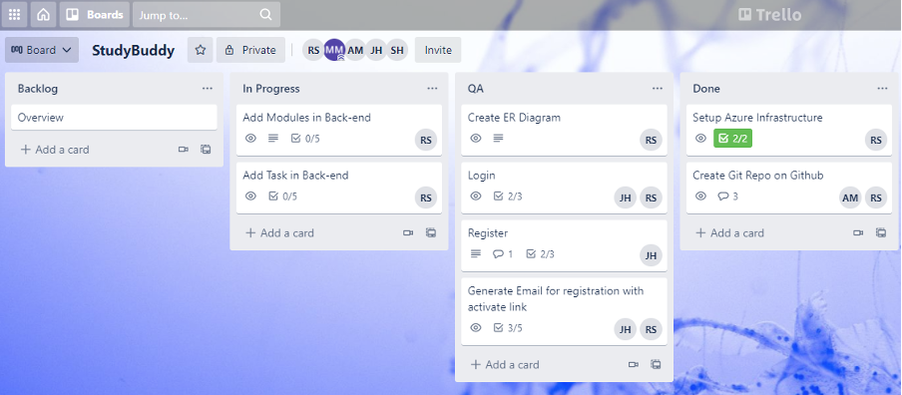

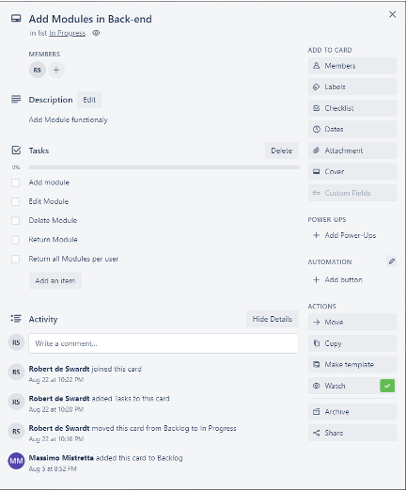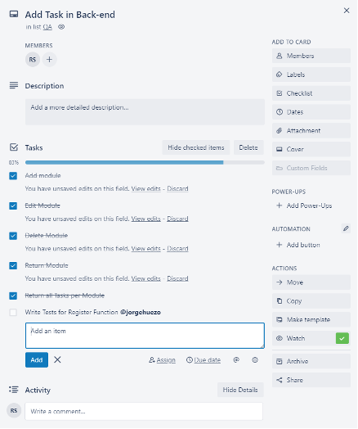

Illustrated below, you can see how two contributors have been working side by side on the project's solution performing their commits and comments on the components that have been worked on.

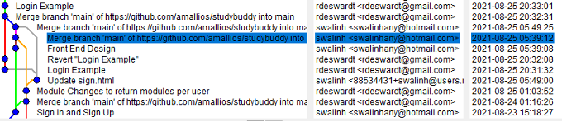

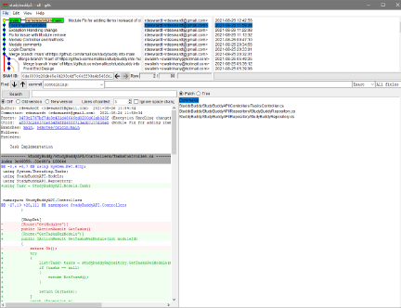

While testing was underway, the relevant person would perform the fix and commit the change to be re-tested if any issues were logged. Below is an illustration of this:

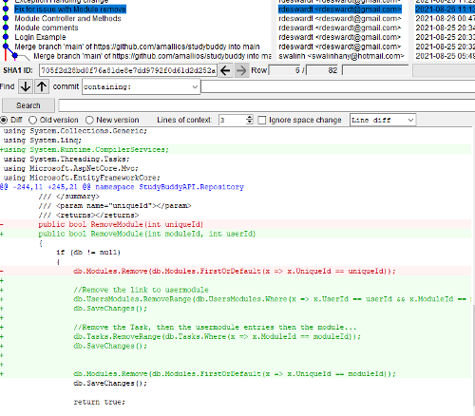

## Testing

The System was developed through 2-week sprints, using test-driven development, to implement its main functionality.

Front-End and Back-End were developed simultaneously then integrated all while being tested separately then together.

### First Sprint

In the first sprint, the basic elements to have a working website where users could register and log-in were the focus. The interface to register and log-in users, the databases corresponding to users and their roles and the required methods for the back-end services were created.

As it was decided that test-driven development was the right methodology for this application we started with **Unit testing**. As it involves the lowest-level components of the application we wanted to ensure everything was working as it was being coded and that we could build up a set of unit tests that ensure the application is working well and that no feature being added or changes made to the code or databases breaks the system. Every time a feature would be added a new test would be created and the feature would need to pass it before continuing.

### Second Sprint

In the second sprint, the elements to allow users to add modules and track their important dates were the focus. The interface to add modules, the databases corresponding to modules and the required methods for the back-end services were created.

We continue with the test-driven development methodology for this application so we continue with **Unit testing** in order to test the lowest-level components of the application as we want to ensure everything is working as it’s being coded and that we could continue to build up a set of unit tests that ensure the application is working well and that no feature being added or changes made to the code or databases breaks the system. Every time a feature would be added a new test would be created and the feature would need to pass it before continuing.

As with this second sprint we approached a functioning application, we needed to integrate more kinds of testing in order to ensure what is being produced meets the originally defined requirements. We designed several functional and usability tests and tested them with real users.

# System Development

As per the project plan agreed at the beginning of the process the backlog was made into two sprints which were executed as per the overall Gantt Chart. We focused our efforts in the project planning phase to create a stand alone product after each Sprint and we assigned milestones to avoid splitting our focus.

This chapter of the report is split in two showing the iterative process that the team followed and it contains Front-End, Back-End and Testing chapters for each Sprint.

## First Sprint (Login & Sign up Users)

The first sprint was the Log in and Sign up functionalities of Study Buddy, that is the user database, back-end services and front-end design and interactions that deal with the tasks assigned to the first Sprint.

### Front-End

During our first sprint, we completed the following tasks related to the front end part of the Log in/Sign up forms:

| Task | Estimated Time |
| --- | --- |
| Create Prototype Design of the user interface | 2 hours |
| Setting up UI project environment | 1 day |
| Create Design for Navigation bar | 1 day |
| Search for Bootstrap/template that fits wanted design | 1 hour |
| Create Design Sign in / Sign up form page | 1 day |
| Bootstrap Integration with HTML | 1 days |
| Finishing touches on Design and updates on Project Report | 1 hour |
| Preparation and conduction of the UI evaluation questionnaire | 1 hour |
| Analyzing Users feedback | 1 hour |
| Redesigning the system according to the Users feedback | 1 day |

#### Login / Sign up Design

Our Study Buddy app is primarily designed for use on mobile devices and desktop computers, since this makes it convenient to use when studying at home or checking anticipated time to due dates.

As a result, we interviewed more than 40 users through an online survey and according to their feedback we designed the site to be both visually appealing and user-friendly. We used a Book picture in the middle of the page to indicate that this is the home page.

In order to sign in one must type in their email address and their password and then press the signin button which is designed with a Blue large button so that it is easy for anyone to realize and Click.

Also, for convenience use, we have combined our Sign in / Sign up forms onto one single page. By Simply hovering over the required form as shown below.

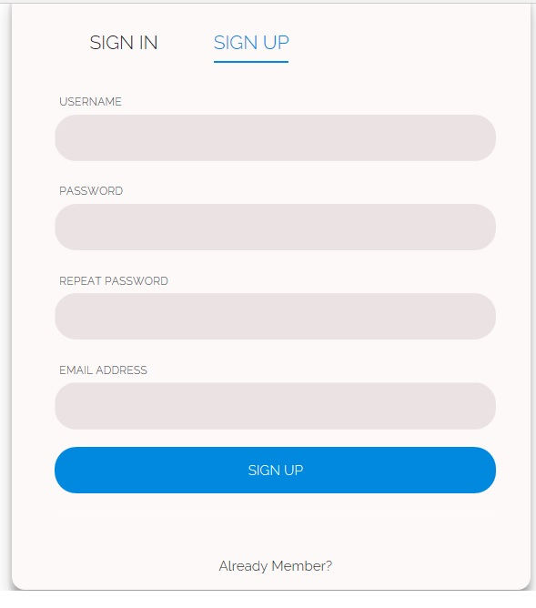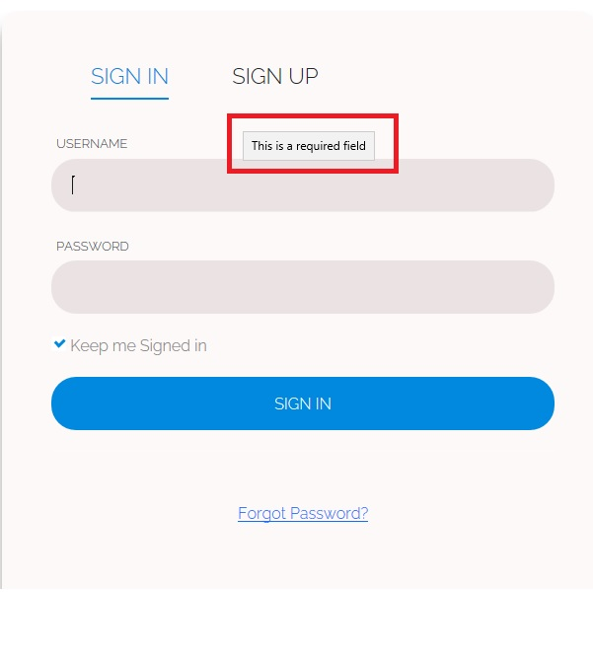

#### Icons Design

When designing our icons, we tried to make our icons as self-explanatory as possible. When a user scrolls around the app, they can view the icons and figure out what each function is just by looking at them. Users who scroll quickly or have difficulty reading may prefer icons, therefore we tried to make them as user-friendly as possible.

### 

### 

#### Required Attribute

Also, we developed the **required** Attribute in sign in / sign up page, required attribute is a Boolean which specifies that the input element must be filled out before submitting the Sign in / sign up Form, to make it easier for the user to see that this field is required before completing the form, as seen below.



#### Hovering

The hover selector is a pseudo-class that allows you to target an element that is being hovered over by the cursor or mouse pointer. When the mouse is hovering over a word, it is styled in a nice blue color to make it easier for users to see where the cursor is now pointing as shown below.

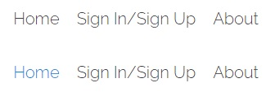

#### Media Design

For our design, our team used only a few images and very little animation as we did not have a tremendous amount of experience in design.

Also we also tried to keep the amount of data required to launch the app to a minimum according to user needs while utilising a cellular or network connection.

We just included simple language to let the user sign in and to indicate what the different symbols meant so that the user could be guided. We didn't require many animations because we wanted our software to be simple and straightforward.

### Back-End

During the first sprint the tasks that were decided for the back-end was based on the 1st sprint for the front-end. This included the setup of the hosted environment and components required for the front-end to integrate into the back-end. Sprint 1 was also used for scaffolding required to make future changes quickly.

Please reference the back-end section for the hosting component to the project.

| Task | Estimated Time |
| --- | --- |
| Create Database | 2 days |
| Create .NET Core Rest API scaffolding | 2 day |
| Create Database Model | 4 hours |
| Create Repository Interface with project required methods | 1 day |
| Create Repository for accessing Database Entities | 1 day |
| Create API methods to be called by the front-end | 1 days |
| Setup database on Azure | 2 hour |
| Setup application service on Azure | 2 hour |
| Publish Project to Azure | 1 hour |
| Testing and Bug fixes | 1 day |

#### Retrospective

A couple of meetings and discussions were held on the database portion of the project to make sure the design is correct as this would be the driver for both the back-end and front-end services. Some small changes were made to the database but our design allows us to quickly make changes and deploy the changes.

Methods In this spring included the following as per the Trello Board:

* Register
* Activate Account
* Email Activation link and Welcome
* Login

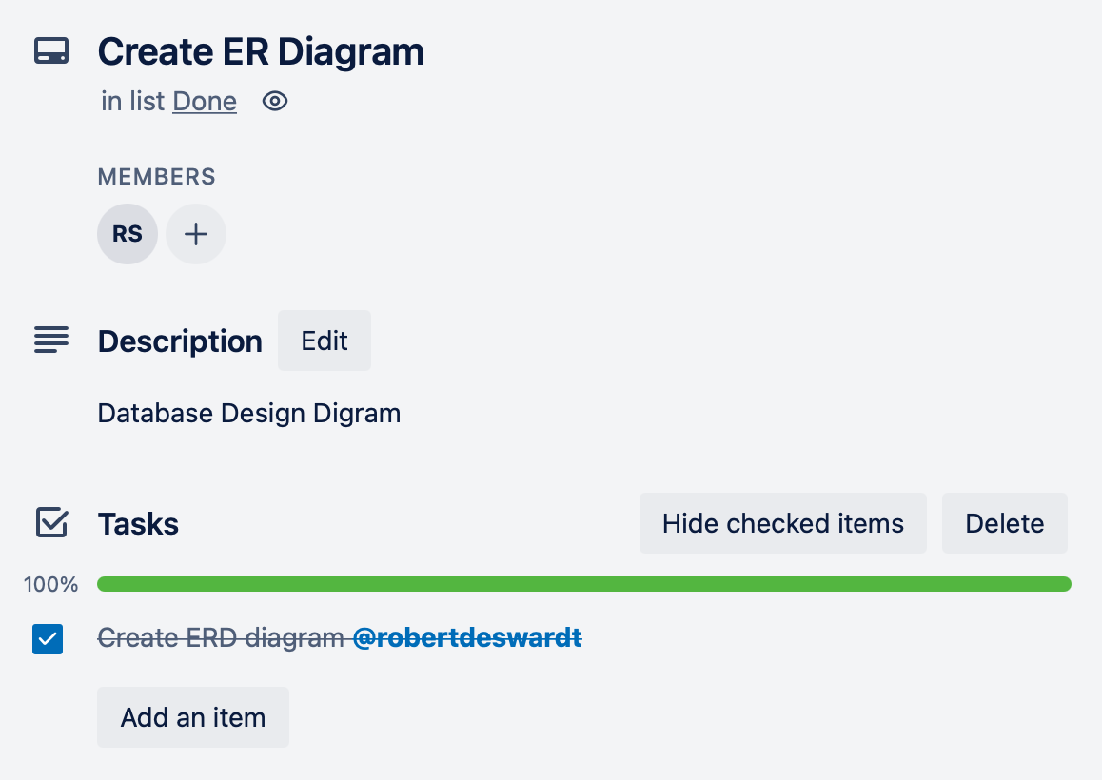 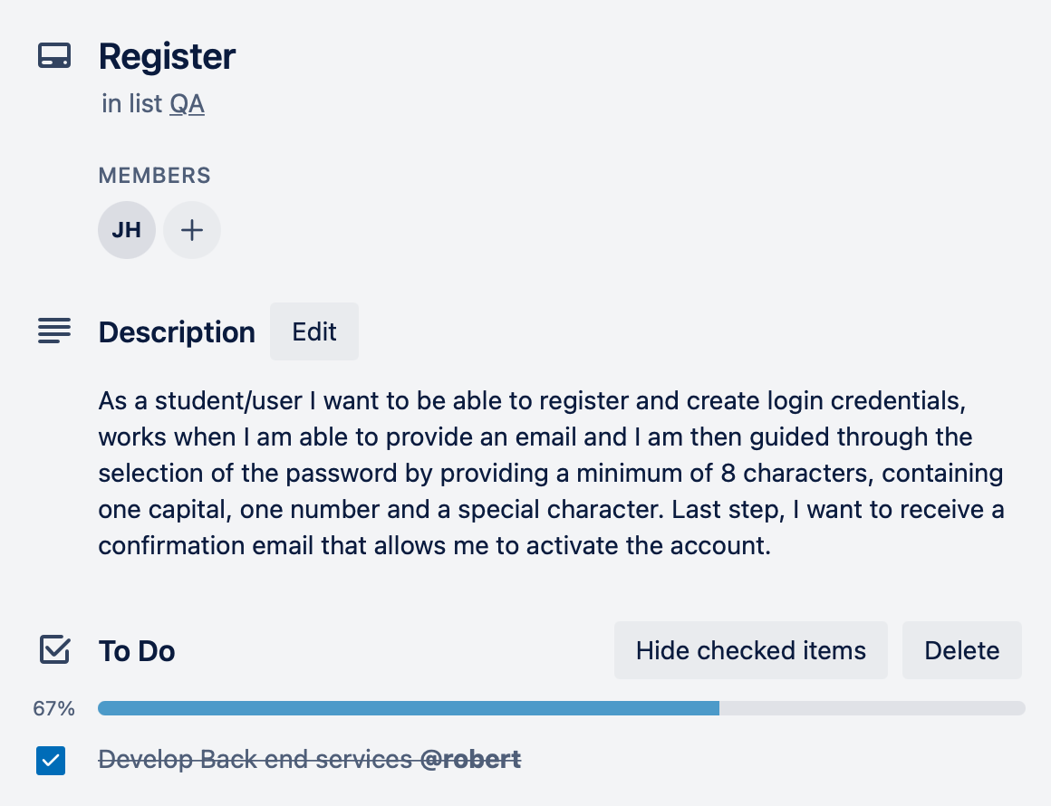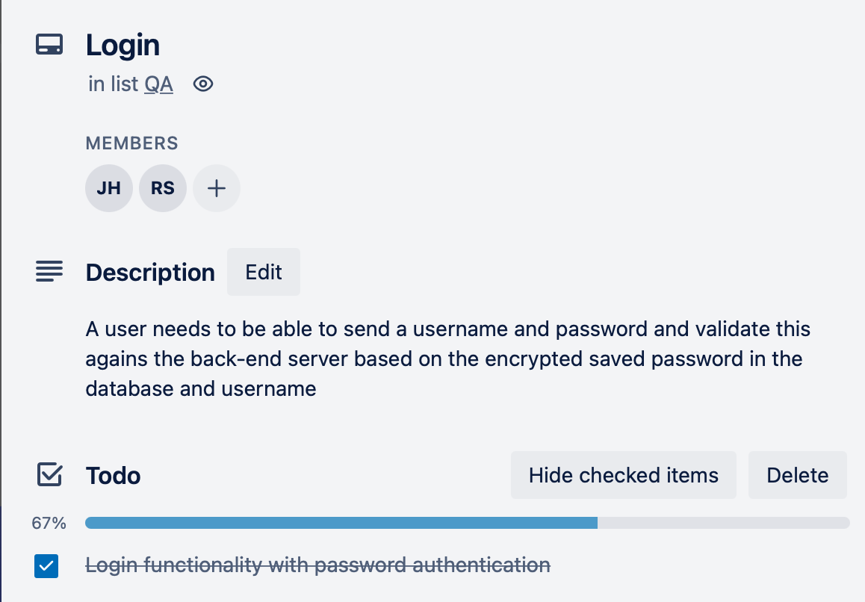 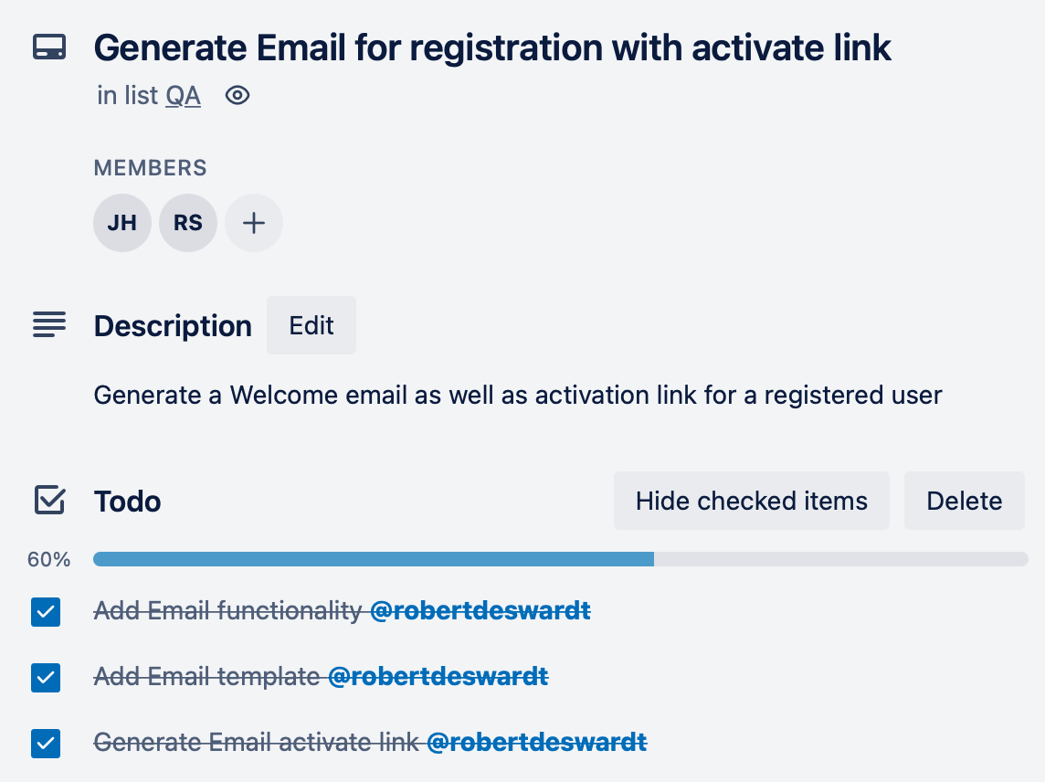

### 

### 

### Testing

We decided to go with a Test Driven Development (TDD) approach for this project as part of the SDLC (Software Development Life Cycle) process.

The main reason why we chose to take this route for development is because this will allow us to get to a working MVP in a much shorter time frame making sure all the features have been tested and working.

From a developer's perspective, TDD is a testing methodology or a programming discipline. A QA engineer uses this technique to begin defining and writing test cases for each small feature of an application. This method tries to answer a basic question: Is the code correct?

The major goal of this strategy is to only change or write new code when the test fails. As a result, there is less duplication of test scripts. This method is often used in agile development environments. Automated test scripts are written before functional code in a TDD methodology. The steps in the TDD approach are as follows:

* A developer creates an automated test case based on the requirements stated in the documentation.
* These tests are executed, and in some cases, they fail as they are developed before the development of an actual feature.

The development team then re-factors the code for the test to pass successfully.

We decided also to use another tool, Postman, to perform integration testing to the REST API service hosted in the cloud, as this can be run on Windows, Linux and iOS platforms, which allowed more members in the team to participate in the testing of the services and application.

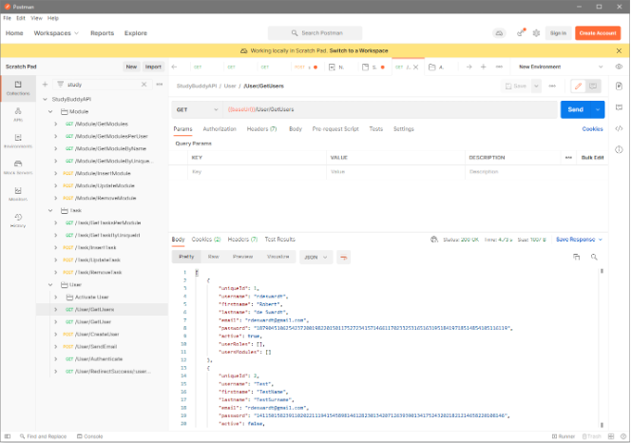

The techniques above allowed us to perform component and functional testing on the individual components and therefore have iterative, incremental changes to our application and contribute towards the final projects. For the complete solution to be tested, we implemented a Unit test project with a test runner that tests each component on the back-end and reports if there is an issue with one of the code changes committed.

Illustrated below is the Unit test project with the results from the test performed:

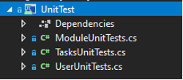

Unit test example:

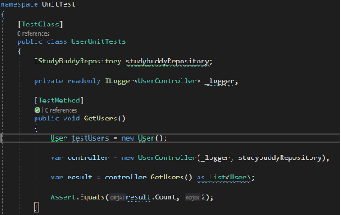

Results:

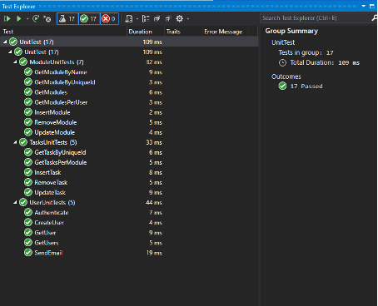

# 

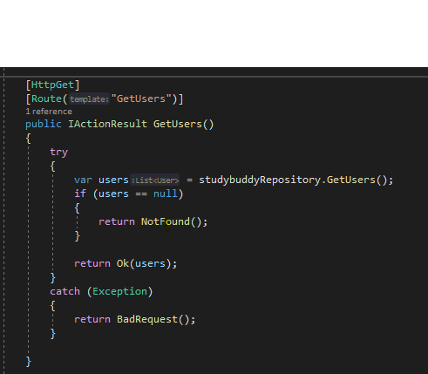

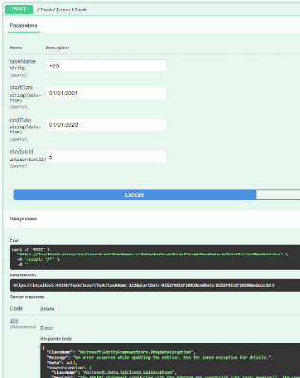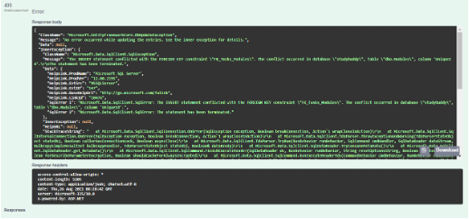

## Second Sprint (Overview & Add Module & Add Task)

The second sprint was the Module Overview and Add Module & Add Task functionalities of Study Buddy, that is the module database, back-end services and front-end design and interactions that deal with the tasks assigned to the second sprint.

### Front-End

During our Second sprint, we completed the following tasks related to the front end part of the Add Modules/Add Tasks page:

| Task | Estimated Time |
| --- | --- |
| Create Prototype Design for add module / add task page | 2 hours |
| Create Design for Add Module form page | 1 day |
| Create Design for Add Tasks form page | 1 day |
| Create Design for Task progress bar | 1 day |
| Bootstrap Integration with HTML | 1 days |
| Finishing touches on Design and updates on Project Report | 1 hour |
| Preparation and conduction of the UI (add Module) evaluation questionnaire | 2 hour |
| Analysing Users feedback | 2 hour |
| Redesigning the system according to the Users feedback | 1 day |

#### Add Module / Add Tasks Design

After signing in from the main page in your application, it will be redirected to add Module page automatically.

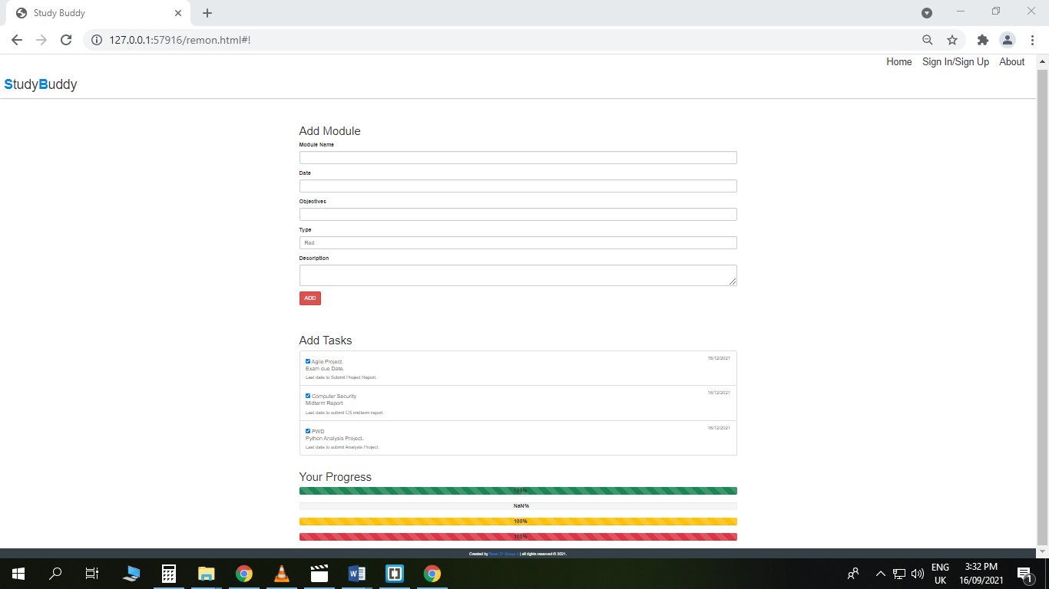

#### Add Module

Add module view has a form to fill out to add a new module to your Studybuddy website that will remind you of your due dates and deadlines for any assignments and examinations. Each user has the ability to name a new module and specify its goals (exam deadline, Quiz time, assignment due date, etc.). And to add the module name to his reminder list, a user must fill up the following text boxes and press the red button to show its importance .

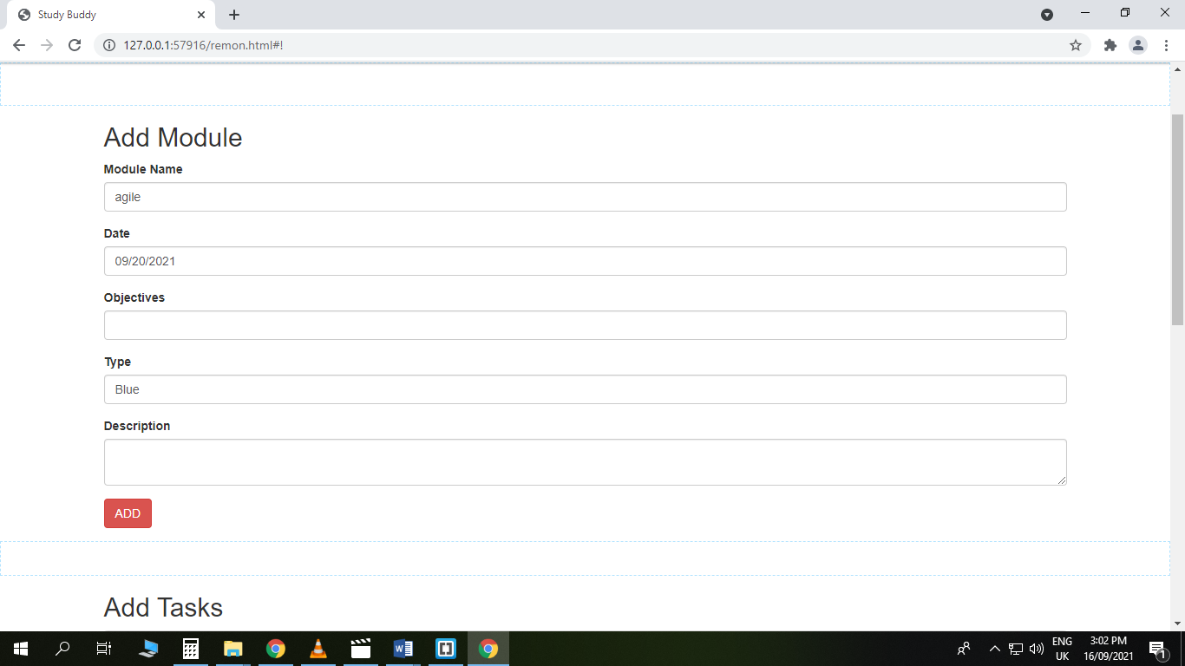

#### Add Tasks

Our Add Module page's second view will be an Add Task Section, which will be shown as a list of additional tasks linked to each module, each with a distinct colour.

As seen below, the Add Tasks section will display the Module name, Task name, relevant comments, and due date.

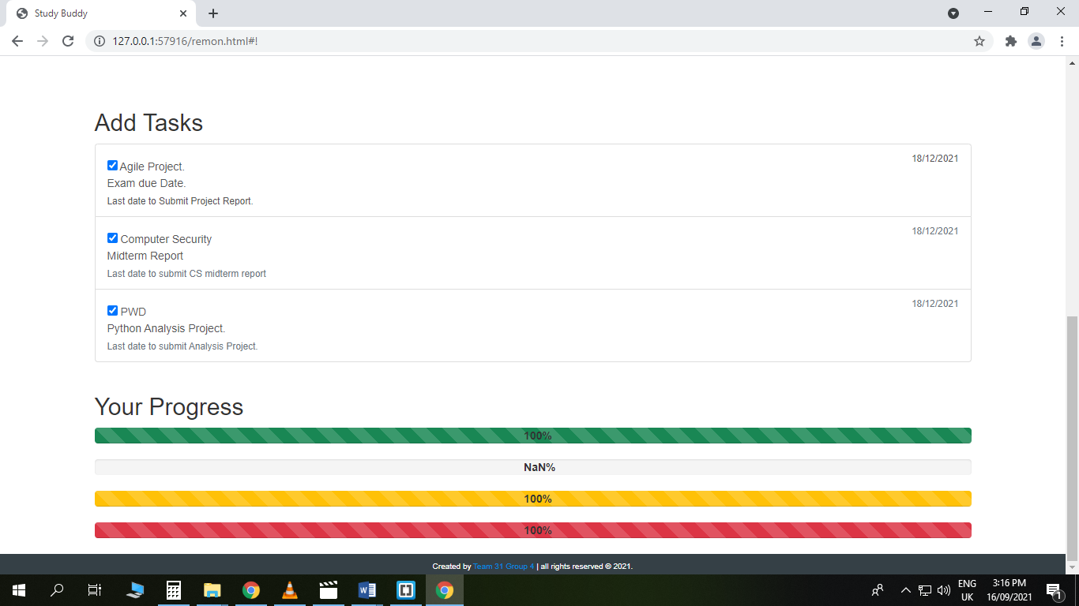

#### Progress bar

While the progress bar will show you how far you've gotten on doing your pending chores, each job will be distinguished by a distinct colour, as illustrated below.

**Exams** --- > red colour denotes the importance of this task.

**Assignment** with tiny Weight --- > Green colour stands growth.

**Quizzes** ---- > the yellow colour should be visible to the user's sight, In order to avoid missing any deadlines.

**Incomplete peer review** ---- > Blue colour stands for Security, Stability.



### Back-End

The second spring required us to complete all the outstanding back-end tasks:

* Add module functionality
* Add Task functionally

| Task | Estimated Time |
| --- | --- |
| Create Module section in repository | 1 day |
| Create Task section in repository | 1 day |
| Update interface definitions to include new methods for the Module and Task functionality | 1 day |
| Test CRUD methods for all modules added | 2 days |
| Bug fixes and integration testing | 2 days |
| Method changes based on scope discussions | 2 days |
| Project deployment to cloud - includes iterations | 2 days |

#### Retrospective

Example mock-up pages were created to assist in calling the services, showing how to perform post requests to the rest API service. Sprint 2 tasks where as follow:

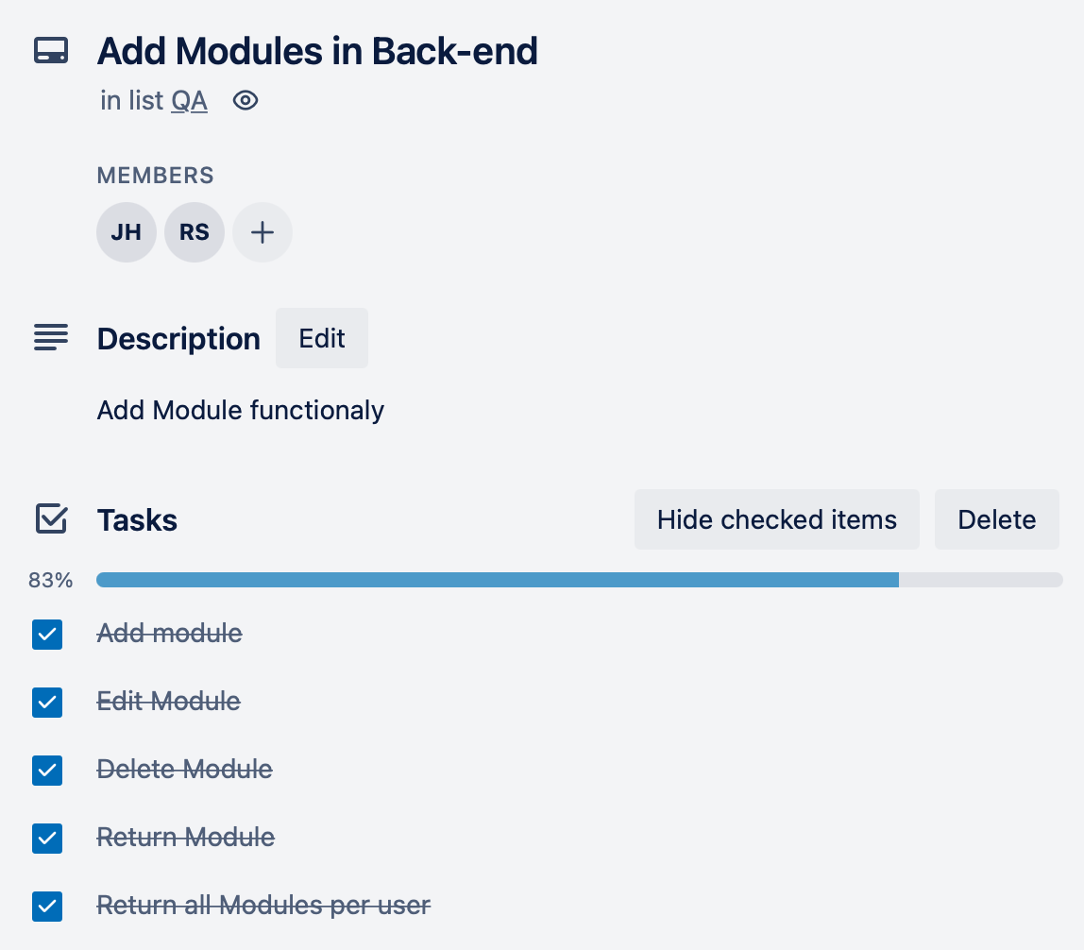 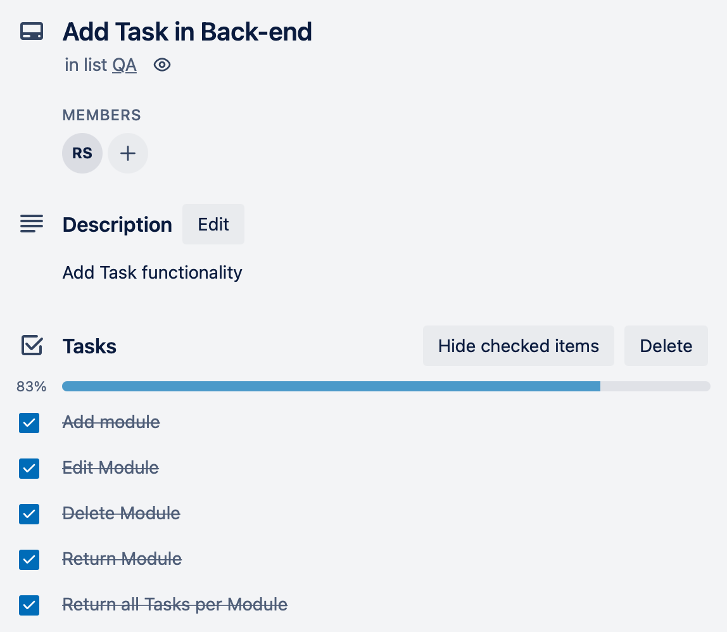

During the testing phase we realised that we require a type for the task items to show the importance of the task for the progress bar indicator.

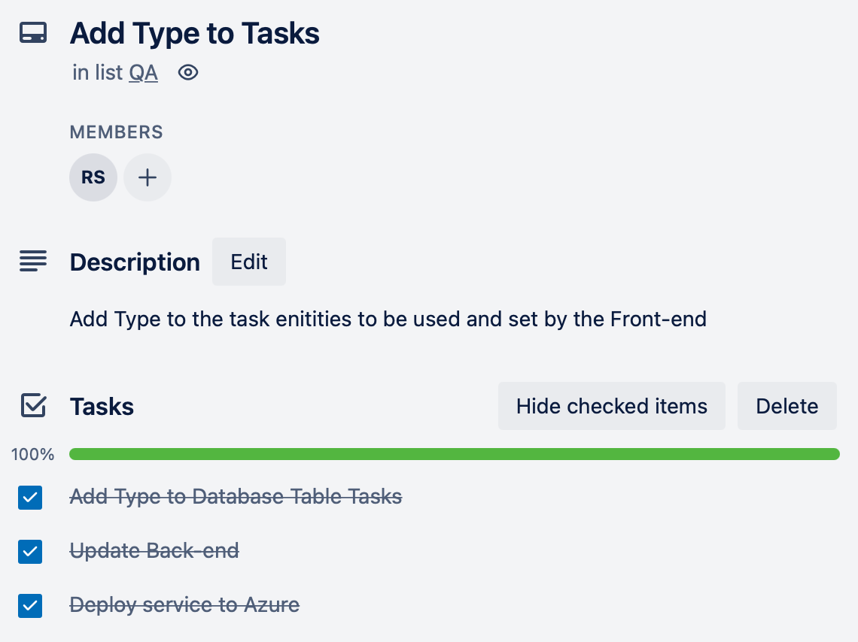

### Testing

As we continued development and entered the second sprint we continued using the same methodologies and systems.

In addition to the unit tests we created several different test procedures to better understand the performance of our system.

#### Functional Test Procedures

We needed a test procedure that would allow us to see how the users interact with our system. For this we designed the following functional test to ensure that the requirements we had previously defined were being met and that users would not find our system difficult to use.

| Test Procedure ID | Objective and Priority | | | Estimated Duration |
| --- | --- | --- | --- | --- |
| 1 | User can sign up | | | 10 minutes |
| Startup | Open browser, go to: studybuddy.com/sign | | | |
| Relationship to other procedures | Needed in order to be registered on the website and add modules in order to track them | | | |
| Procedure | | | | |
| Step and Test Case | Activities | Examination of result | Actual Result | Test Result |
| 1 | Click on the sign up tab | The user should be prompted to fill a form with the necessary data to create an account |  |  |
| 2 | Click on the sign up button | The user should receive a message that their account has been successfully created and that a confirmation email has been sent for activation. |  |  |
| 3 | Click on the activation link received via email | The user should be brought to their homepage where they can add modules and see their progress |  |  |
| Stop. | | | | |

| Test Procedure ID | Objective and Priority | | | Estimated Duration |
| --- | --- | --- | --- | --- |
| 2 | User can sign in | | | 10 minutes |
| Startup | Open browser, go to: studybuddy.com/sign | | | |
| Relationship to other procedures | Needed in order to be log onto the website and add modules in order to track the | | | |
| Procedure | | | | |
| Step and Test Case | Activities | Examination of result | Actual Result | Test Result |
| 1 | Click on the sign in tab | The user should be prompted to fill a form with an email as username and a password |  |  |
| 2 | Click on the sign in button | The user should receive a message that their account has been successfully validated and be brought to their modules page |  |  |
| Stop. | | | | |

| Test Procedure ID | Objective and Priority | | | Estimated Duration |
| --- | --- | --- | --- | --- |
| 3 | User can add modules and update progress | | | 10 minutes |
| Startup | Open browser, go to: studybuddy.com/sign and sign in | | | |
| Relationship to other procedures | Only accessible if the user has an account on the website | | | |
| Procedure | | | | |
| Step and Test Case | Activities | Examination of result | Actual Result | Test Result |
| 1 | Add module | On their module homepage the user should be able to fill a form with a module’s relevant data and add it |  |  |
| 2 | Update module | Works when for each module created the user has access to an editing functionality that allows to add event based information along with details about notification rules. |  |  |
| 3 | Update module | Works when either form the main page or from the module details page I can change the progress through a fader |  |  |
| Stop. | | | | |

#### 

#### 

#### 

#### User Test Procedures

Our design philosophy is aligned with making a product that is easy to understand, easy to use and that users feel like it useful. We used the **UMUX** questionnaire to get feedback from users and to ensure the product was usable and accessible.

|  | Strongly Disagree | 1 | 2 | 3 | 4 | 5 | 6 | 7 | Strongly agree |
| --- | --- | --- | --- | --- | --- | --- | --- | --- | --- |
| This system’s capabilities meet my requirements |  |  |  |  |  |  |  |  |  |
| Using this systems is a frustrating experience |  |  |  |  |  |  |  |  |  |
| This system is easy to use |  |  |  |  |  |  |  |  |  |
| I have to spend too much time correction things with this system |  |  |  |  |  |  |  |  |  |
|  |  |  |  |  |  |  |  |  |  |

#### HTML Testing

Finally we tested the correctness of our HTML using a couple different validators. The feedback was brought up to the Front-End developer and adjustments were made

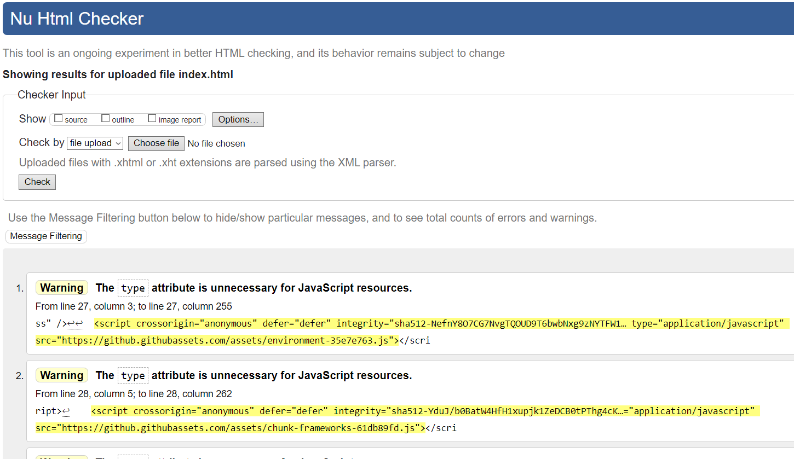

# 

# Analysis

The aim of the application being prototyped is to improve the ability of students to track their progress and has been specifically designed for students of all ages to gain control over their studies in a more efficient way than the traditional general purpose time management and productivity software.

In the following example modules.org allows to create modules and create a calendar for the lessons

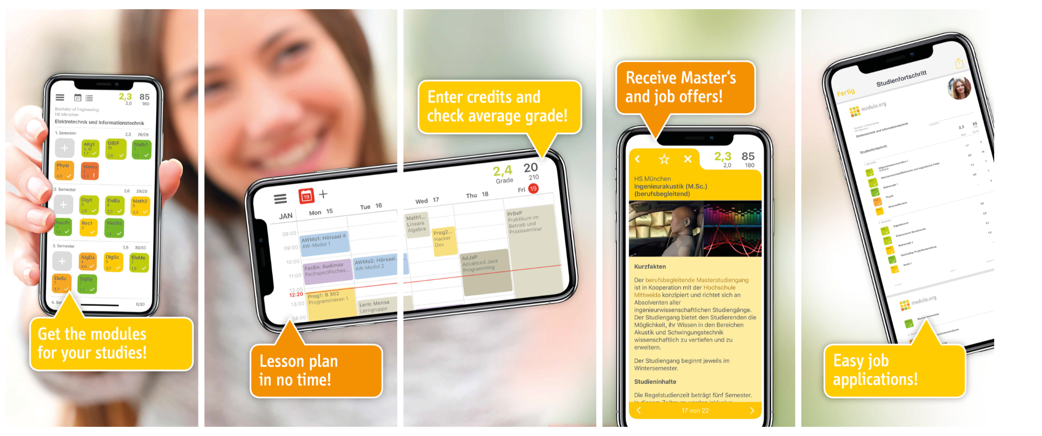

Such functionalities can be also achieved as a combination of multiple production tools, for instance I could set reminders and calendarize events using google calendar and encode the activities as tasks in productivity tool such as trello or similar

The following is a typical view of google calendar :

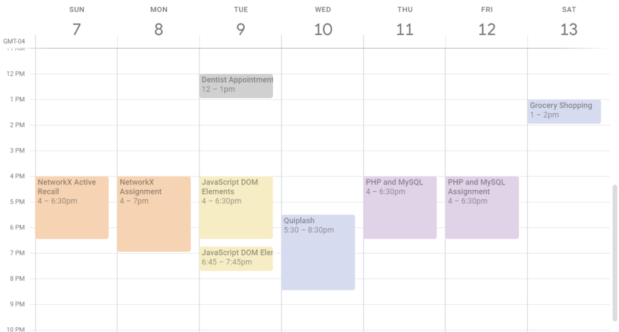

while Trello could be used for tasks and status

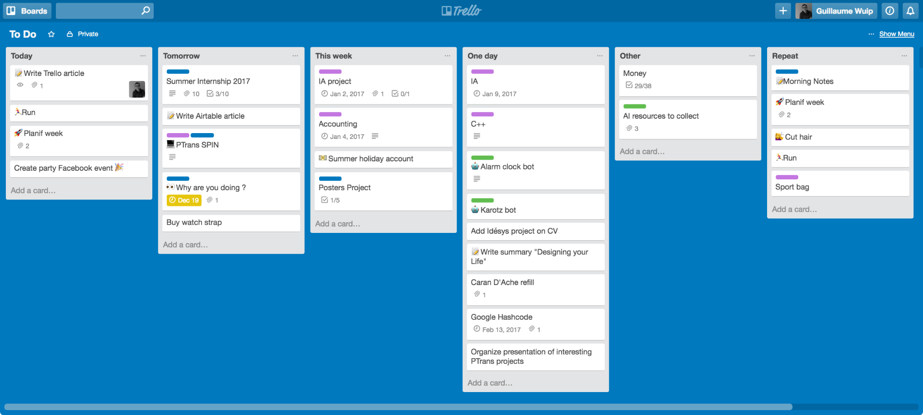

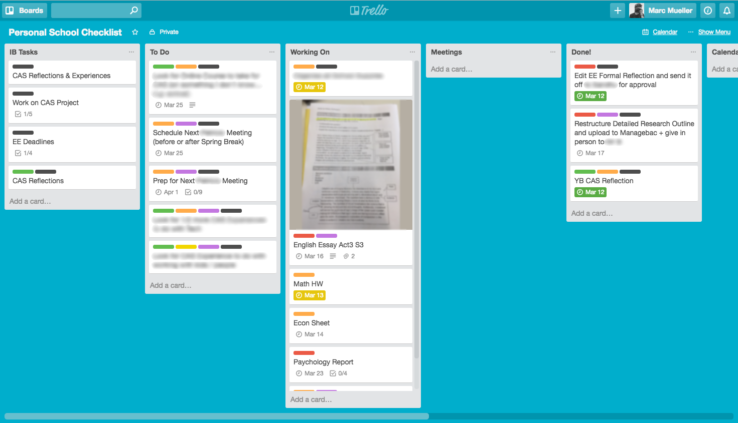

Studybuddy will focus more on the ability to track the progress and make it really easy to stay on top of deadlines and upcoming assignments.

Tools like google calendar and Trello as much as other Microsoft productivity tools might still be of help for people so Study Buddy should provide account sync capabilities (not as part of the MVP being prototyped)

## Risk Assessment

| No. | Risk | Danger 1-5 | Effects | To Prevent | Solutions | Responsible Person |
| --- | --- | --- | --- | --- | --- | --- |
| 1 | Poorly defined project description | 3 | The team does not entirely understand the project and may spend too much time making important decisions | N/A | Organize meetings with Product Owners as often as it is needed to clear things up | Scrum Master |
| 2 | Troubles connecting and integrating between Front-end and back-End development | 5 | A big part of the ‘A’ requirements cannot be finished | Start early, make it a top priority | Focus all manpower on establishing the integration | Product Owner |
| 3 | Workload in other courses | 3 | Less focus on the project, programmer may be out for a long time | Stick to the plan, organize your homework according to the work schedule | Focus all your energy into finishing what’s due to clear the stress, then come back | Product Owner |
| 4 | Incompletion of tasks by the end of the sprint | 3 | Falling behind the schedule and delaying the work | Try to assess time of tasks as well as possible | Learn from it and use retrospectives to make later sprints more efficient | Product Owner |
| 5 | Inefficient estimation of time assigned for the project | 3 | Incomplete product | Update the backlog and follow the Scrum plan | Re-estimate the requirements and time if needed | Product Owner |
| 6 | Product Owners do not have time for the group | 3 | Crucial information may come late | Try to get regular meetings with them | Call or email project owners if needed and hope for a quick answer | UX designer |
| 7 | Lack of communication | 2 | More chance of misunderstanding | Try to make it to all meetings | Write all information down and send it to those who couldn’t make it | Scrum Master |
| 8 | Illness | 2 | Programmer may not be able to leave home | Try to get enough healthy food and good sleep | Work from home or work up the hours during free time | Scrum Master |
| 9 | Inefficient estimation of time assigned for a sprint | 2 | Failed sprints | Try to give yourselves more time for each task | Hold retrospectives to learn from it and re-evaluate time, maybe spend more time on the project | Scrum Master |
| 10 | Over- estimation of skills | 2 | Implementation of some requirements may take longer time or be done wrong | Gather as much information about the task as possible before diving into programming | Ask someone who may be able to help and explore the material better | Scrum Master |
| 11 | Absences | 2 | Programmer away for some time | Try to schedule other activities according to the work schedule | Work up the hours, e.g. use weekends, respect the working agreement | Scrum Master |

## Risk occurrences

| No. | What happened | Effects | Solution |
| --- | --- | --- | --- |
| 1 | The project's scope was unclear. | Scope Creep effect as the team was unsure about the project's scope. | A few meetings have been arranged to go through the project in further depth and to clarify things up. |
| 2 | Team Member was sick | Delayed Tasks consequently delayed schedule | Team Spliced his tasks on other 3 members |
| 3 | Lack of communication from the Product Owner | The team got wrong information from Product Owner | The team questioned the Product Owner if everything was clear at the following meeting. |
| 4 | Lack of communication between the Product Owners and the team | The meeting was delayed | The team used the time to work on the report while waiting for the Product Owner to arrive |
| 5 | Workload in other courses | The team conducted the prototype questionnaire with users, however due to an exam in another course, we were unable to continue working on the project. Several tasks that were supposed to be completed in Sprint 1 were not completed. | The team needed to keep working on the sprint's outstanding assignments. |
| 6 | Workload in other courses. There were a lot of significant deadlines. | The whole team decided to focus on finishing other projects | The team did not assign too many tasks to the sprint, so they would definitely manage to finish it |
| 7 | Exam session | The team had to put the work on hold while studying for examinations. | The team meticulously scheduled the remaining sprints and calculated the time for the remaining tasks before putting work on hold. |
| 8 | Integration phase took way longer time than was expected | Unfinished tasks by the end of the sprint | The team spent its time studying and resolving the problem, deferring less critical duties. |

# 

# Evaluation

The project was split into 5 domains (Process, Product, Front-End, Back-End and Testing) with the five authors having the accountability for each. We considered it appropriate to evaluate the project from each domain’s point of view.

## Process

The team spent a significant amount of time considering the process in depth. Since we all happen to be experienced professionals we are used to taking shortcuts in our professional life depending on the size of the task in hand.

During this project we all took a step back and discussed thoroughly how the different Agile strategies fit into each other. We discovered the limitations of each and discussed in length the differences between the theory and practice, exchanging ideas and stories from our respective workplaces.

This exercise did teach us a lot.

A Project Manager’s role is exactly to facilitate the process, make sure that there are opportunities for the team members to discuss and try to focus people’s attention to certain tasks. Not always the most charming role, but having worn this hat we will certainly be able to work better with project managers in the future.

Last but not least, we did have fun. Along with getting to know and appreciate each other’s reaction in tense moments, when a milestone was slipping or when we were caught by surprise when underestimating the complexity of certain tasks. All team members were quick to jump in and save the day.

On reflection, from a Project Manager’s point of view, I did fail to foresee certain circumstances that could have made the project run smoother. Having known the extent of our time limitations in the summertime I should have built in much more buffer than what I did.

## Product

### End User Product Evaluation

In order to be easily accessible by the designated end users the application should be developed with a mobile first approach and using the material UI designs as much as possible.

Material UI has been selected as it has gained a lot of traction in the last few years and is being supported by multiple UI frameworks and this should avoid many usability issues as well as speed up the UI implementation.

Users might connect from several time zones, it is fundamental to receive notification in the relevant time zone for each specific user. The time zone should be set automatically according to the device being used to make the connection and/or geo-referencing the IP address from which the connection is being established.

Losing information could be really frustrating therefore the Study buddy application should allow the user to back up the information and store the backup in one of the user’s favorite cloud services or locally on the user’s machine.

As mentioned in the previous section, integration with 3rd parties application even though not being part of the MVP developments is a critical part of the application since many user expect to be able to export information and make them available to their favorite apps

Implementing an open architecture and providing the ability to sync accounts with most used apps and networks should be part of the evolution plans.

### 

### Internal User Product evaluation

In order to understand how the application is being used overtime the application should be geared with tools for the analysis of traffic, being a web based application the best tool is probably google analytics

Below a screenshot:

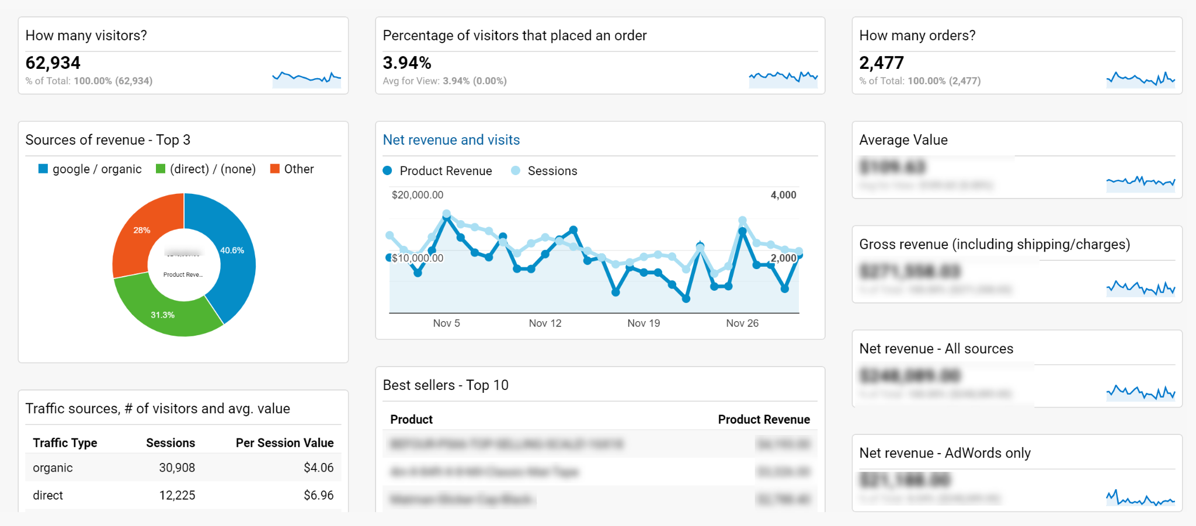

From a system perspective the application should be as available as possible to the end users even though it is in MVP therefore should be geared with a minimum set of monitoring services.

Azure, the cloud platform selected to build the prototype provides such services for the different tiers of the stack as shown below:

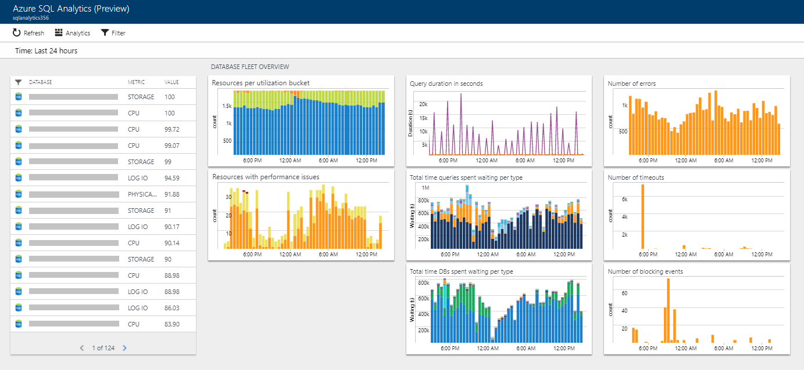

## Front-End

### Evaluating Design

**Principle 1**: Allow easy access to application

Our application relies on widespread easy use and we have to market it that way. If a user has initial trouble getting on the system or trying to make an account they may disregard using it.

Making a paper studying progress list is a pain for many users, but they would rather take a few minutes to make a list than to spend a whole afternoon troubleshooting their new study buddy list app.

Logging in should be something that is very easy to do and not require a lot of cognitive or physical thought. Our log-in Button is located in our Navigation bar in big Black text and it turns into Blue when hovering on the word to make it clear for the user that he will use this feature now.

All it takes to log in is an e-mail address and a password. The log-in was designed to just require an email address and password to log in so that it is easier for the user and allows them to have their own account.

**Principle 2:** Design for Security

Security is extremely important. Many users can be careless with passwords and not change their passwords very often or use the same password for multiple applications. We have to be prepared for that issue as well as allowing for a user to not have issues accessing the app by creating some obscure password that they won’t be able to remember. Being able to log off of the system on the device allows for some sense of security that the lists won’t be compromised if someone gets a hold of the user’s device.

**Principle 3:** Design for ease

One of the most significant features of our software is that it allows users to add as many Modules and tasks as they like on a regular basis. Also our software allows users to get to their task list whenever they want from their mobile device and add them in an orderly manner (coloring schema).

**Principle 5:** Visual Aesthetics

It is critical to have something that is appealing to the eye in order to sell it. One of the reasons for Apple's success has been the aesthetically pleasing nature of some of their software. People appreciate things that look beautiful, and our app is full of them, with a book image on the front and bright graphics throughout. This maintains the user's attention on the app and increases their enjoyment of it. Also we utilized the friendly font text Arial.

**Principle 6:** Support Diversity of Users

We made every effort to keep our design as straightforward as possible. We could only examine so many variables, so we took gender, age, and a range of user ability levels into account. We believe our design is simple enough for anyone with even a basic grasp of computers to understand.

## Back-End

We decided to create a back-end that is not dependent on the technology we will use for the front end. This is entirely server-side, while the front end will be client-side.

The back-end needed to be de-coupled from the front-end, making it possible to develop a front-end, either a website or a mobile application or even a windows application.

For future development, having the back-end de-coupled allows us to provide multiple types of User interface applications for various users who prefer a native application running a mobile device.

Please refer to the back-end section on the reasons for choosing the technology stack.

The biggest problem we had within the team was the experience in back-end technologies, so we had to rely on a single person to develop the back-end and assist with the front-end development.

This was a significant risk as numerous things could happen to the sole person developing the back end. The way this risk was mitigated

· We had incremental check-ins

· Reviews by the team were done frequently

· Training the team on this new technology. .NET Core.

· Individual component testing

We as a team learnt a lot about the options available to us for developing this back end. A lot of research was done, and watching tutorials on how to develop within the .NET Core platform, which is platform agnostic. This was also the first time the team deployed to the Azure cloud, as this was the first deployment done to Azure Hosted.

We have had a lot of learnings, and the next time we will make sure we have more members in the team that can code within the platform itself that would allow us to share the workload better.

## Testing

As it was decided early on, we developed StudyBuddy using test-driven development so for the technical aspects the way we would test would be through unit tests. In retrospect, it’s easy to see why TDD is such a popular system to create software.

The test set allows one to gain a lot of insight whenever there is a problem or when the app is not working in the expected manner. As the tests are created along the software we ensure that every basic function is performing its task as expected and when we add any new code that this code will be compatible with the rest of the app. In short, TDD worked as expected, allowing us to build a very complete test set that allowed us to code in a very secure and concise manner.

As for the Functional testing we designed 3 procedures that would be testing the main functionality of the app; which means allowing users to sign up to the service and to create their dedicated studies tracker by adding modules with dates to track. Additionally we used a UMUX test to gather more general feedback from users. The results we obtained from users were of great help to design an interface that was accessible and friendly to as many students as possible and specially for our target demographic. They were useful as they allowed us to see how users interact with the system and what parts work well. From these tests we would revise the results as a group and then add to our Kanban the aspects that might need tweaking or changing based on the feedback and assign them to the respective developper.

# Conclusion / Summary

## Outcomes

The MVP can be used to test the initial idea and could be distributed among a community of students willing to test and provide feedback about the different functional and usability aspects.

## Development Practice

The Kanban was selected as the main instrument of collaboration and Trello as the technical tool to configure the activities and track the status of the activities as well as encode the details of such activities.

The team was able to perform two full scrum sprints and deliver a relevant number of functionalities including a number of change requests that have been added along the way while the application was being developed.

The team is composed of experienced individuals so the scope was tailored in order to be feasible within the available time frame and functionalities developed according to the initial plan.

We did not make the prescribed card estimation game but we preferred to leave the choice to each individual on which task to pick and we preferred to maximize the development capabilities in terms of development hours being executed by each member.

Since the resources were fixed in terms of team members and amount of hours to be made available by each we should have achieved the maximum amount of deliverables feasible with the given resources.

Many challenges were faced as a distributed development team, the first was the different time zones that made synchronous communication (such as MS Teams or Google Meet) available only for a short fraction of the day therefore we had to rely heavily on the capabilities provided by asynchronous communication tools such as chat (Slack), Kanban Task management (Trello), Code Versioning (Git) Document Management (Google Drive and Google Docs/Slides)

## Future Plans

The application has plenty of room for improvement in functional terms but it has been developed in a way that the initial set of features are solid enough to be built upon and not require a full rewrite in order to provide the desired evolutions.

The main area for evolution are related to integration with 3rd parties therefore making the app as part of a larger ecosystem.

# Appendix - User Manual

1. **Creating an account**
   1. **Click on Sign In / Sign Up on the landing page:**

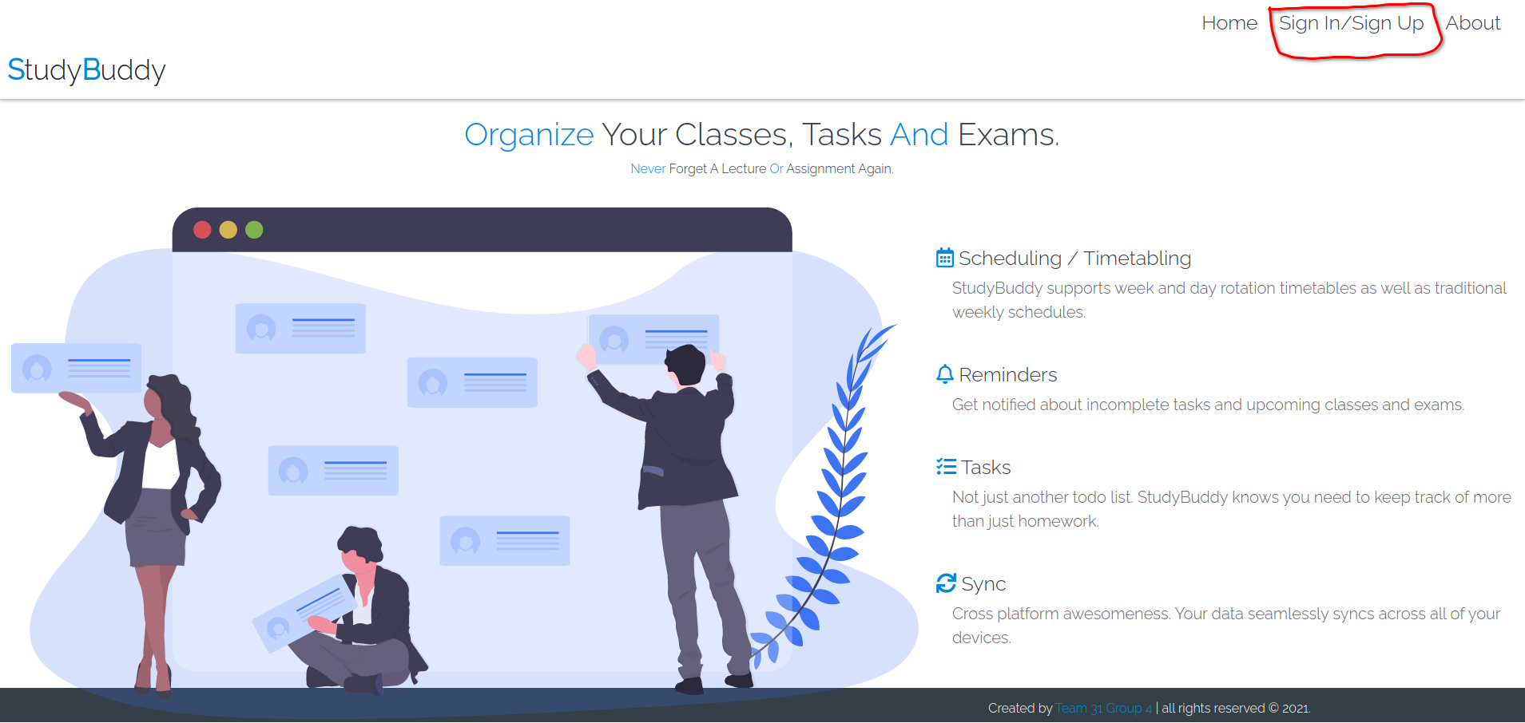

* 1. **Fill out username, password and email address**

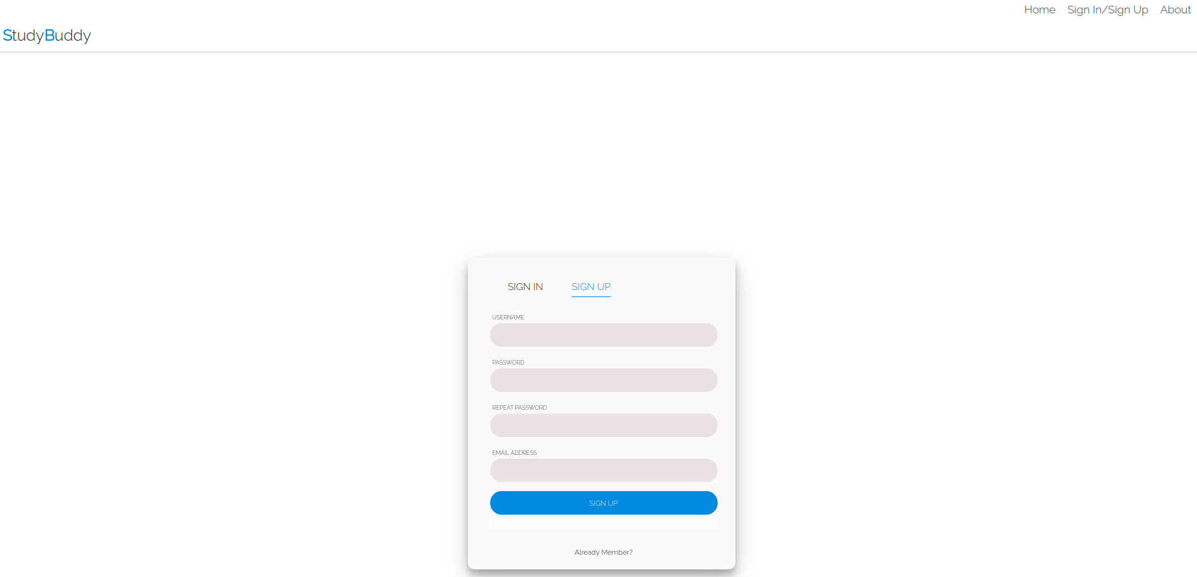

* 1. **Verify your email address by clicking the link in the email received**

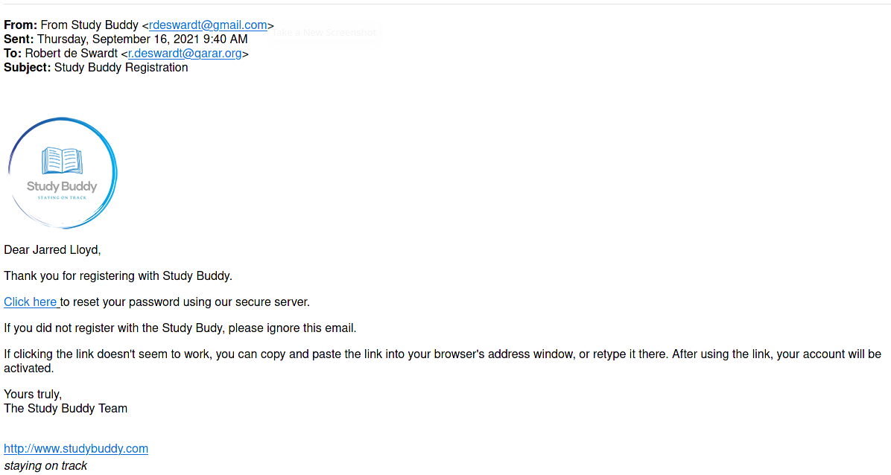

* 1. **Log in to your account**

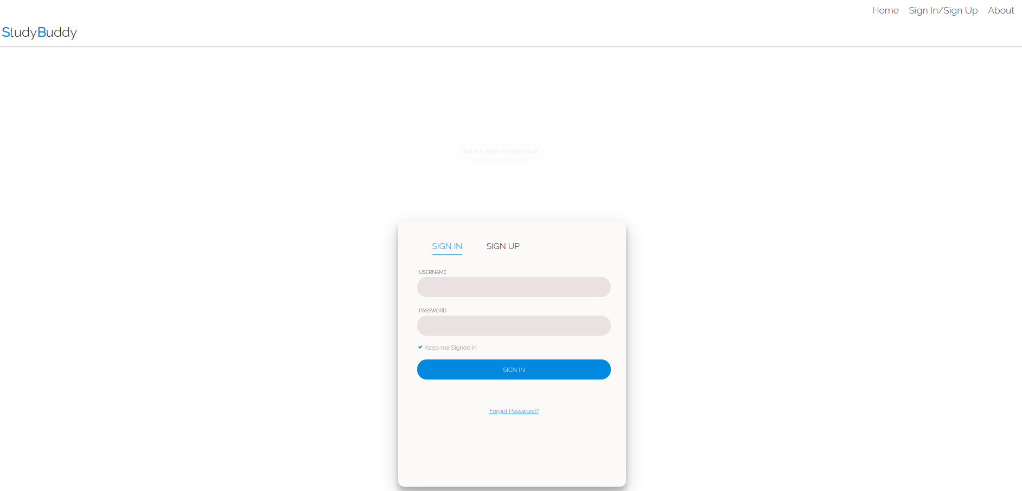

1. **Overview, Tasks and Modules**
   1. **Add / Remove new modules and tasks**

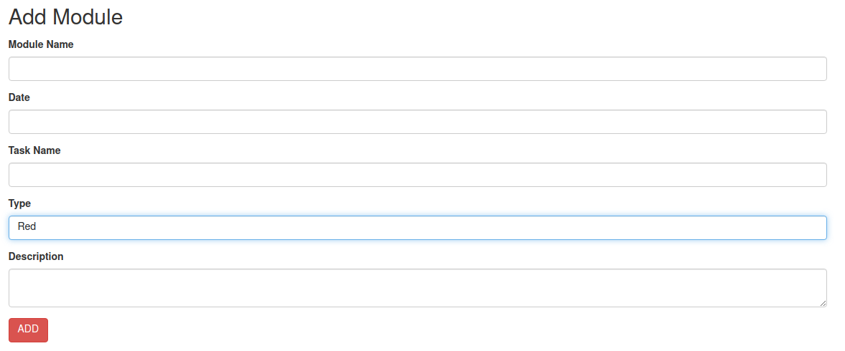

* 1. **Visualise your progress by using the checkboxes.**

